This media release is embargoed until April 19, 10 a.m. Pacific Time
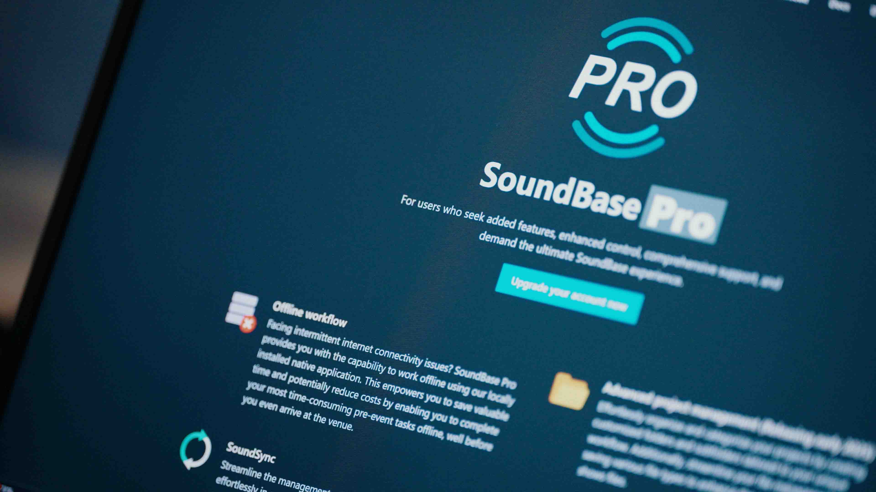

SoundBase adds Lectrosonics and dives into WMAS
At NAB, the universal RF coordination tool adds Remote View to its Pro version and shows many more features

Las Vegas, April 2026 — SoundBase, the user-driven RF coordination and collaboration tool, has added Lectrosonics DSQD to its roster of supported devices, alongside wireless systems from manufacturers Sound Devices, Shure, Sennheiser, and Wisycom. Also, founders Matt Dale and Donny Kuser have started integrating WMAS wireless, which will soon make SoundBase the first tool that is able to coordinate both narrowband and wideband wireless systems. With Remote View, SoundBase is launching a smart tool to share live monitoring data with multiple production team members without increasing network traffic. If at NAB, visit SoundBase at the Sennheiser booth in Central Hall , #4931, or online on their new YouTube channel.

Remote View — a smart way to share wireless data
Up until today, wireless operators who needed access to hardware data across a broadcast production or show site all had to download the same monitoring software onto their devices to be able to see what was going on — a lot of network traffic for the same result. Remote View of SoundBase addresses this issue and streamlines the workflow. For Remote View, SoundBase acts as a built-in web server, and lets users generate shareable links with customizable views for collaborators and wireless users. It also allows operators to isolate the control network by hosting the server on a separate network interface card.

“Remote View is a much smarter way to share wireless hardware telemetry across multiple endpoints without running duplicate instances of software,” says Donny Kuser, co-founder of SoundBase. “By reducing connections and network traffic, your control network stays efficient and your gear stays responsive.”

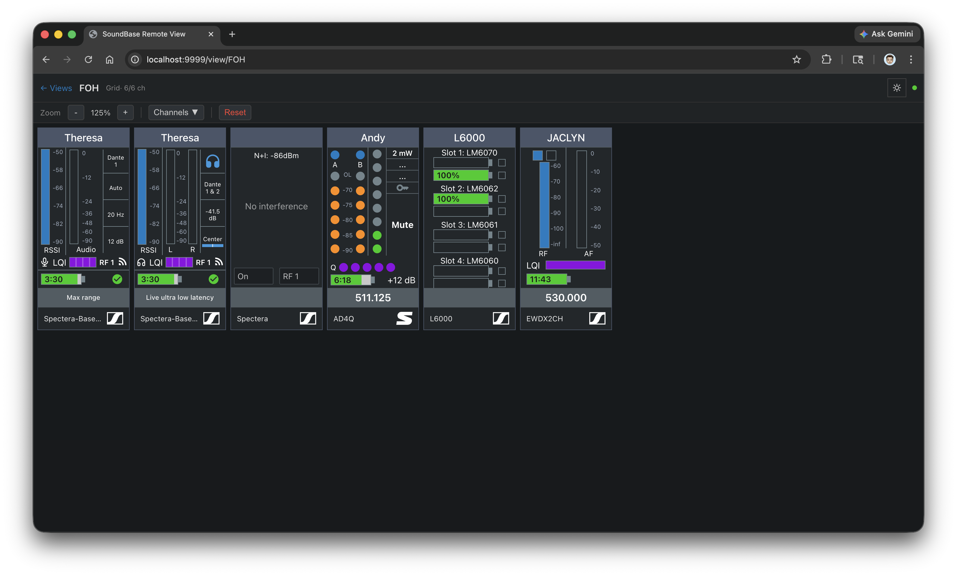 | With SoundBase’s Remote View, you can share wireless hardware telemetry across a production without running duplicate instances of software

More wireless added
Following the addition of Sound Devices Astral wireless microphone systems for ISE 2026, SoundBase has now added Lectrosonics DSQD wireless microphones. At NAB, SoundBase will also demo a limited monitoring and control feature set for Spectera, which will become available soon after the show.

Other feature updates
Manufacturer-agnostic wireless audio coordination and control, production management as well as team collaboration in a single solution — this is what SoundBase stands for. Backed by a passionate community on Discord, the app is constantly updated and expanded to include new features that make the lives of broadcast and live audio RF coordinators easier.

The grid monitoring cards can now carry images of e.g. the artist on the respective wireless channel for an easier and immediate overview, especially with larger productions. Notation cards have been added, so the engineer can add comments and notes to organize their workspace. A more flexible layout control has been realized, cards can now be resized individually. Also, columns can now be hidden in the list monitoring view for a more customizes layout and to better fit the monitoring screen.

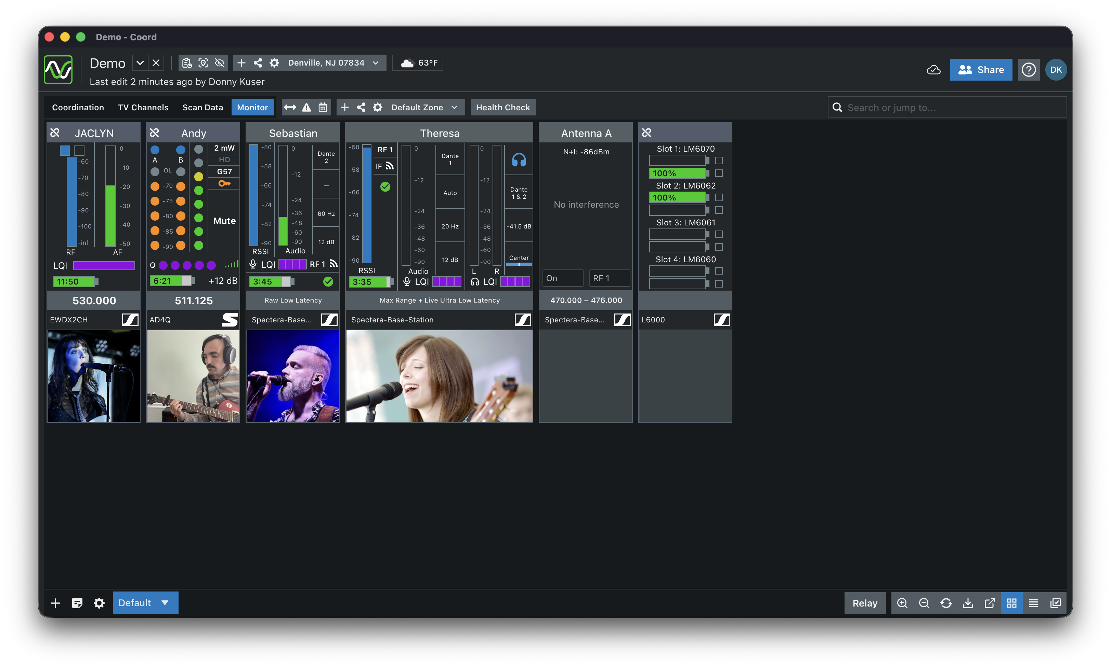 | For an easier and more immediate overview, SoundBase now allows the grid monitoring cards to carry pictures

As a special NAB preview, the SoundBase team will demo the upcoming Audio Monitoring (Beta) feature for SoundBase Pro. It allows operators to access live audio directly from the monitoring page for real time monitoring with flexible soloing and routing options. The release date is still to be determined.

Health Check
SoundBase’s Health Check has become an important feature for both broadcasters and live sound specialists. “During large productions, and especially during big music festivals with multiple stages, the most perfect frequency plan can suddenly become obsolete and has you frantically searching for solutions,” says Matt Dale, co-founder of SoundBase. “That’s why we developed the Health Check function, and it’s very rewarding to see that engineers absolutely love it.”

The Health Check of the SoundBase app helps engineers see if their frequency planning is still accurate as a live event progresses | 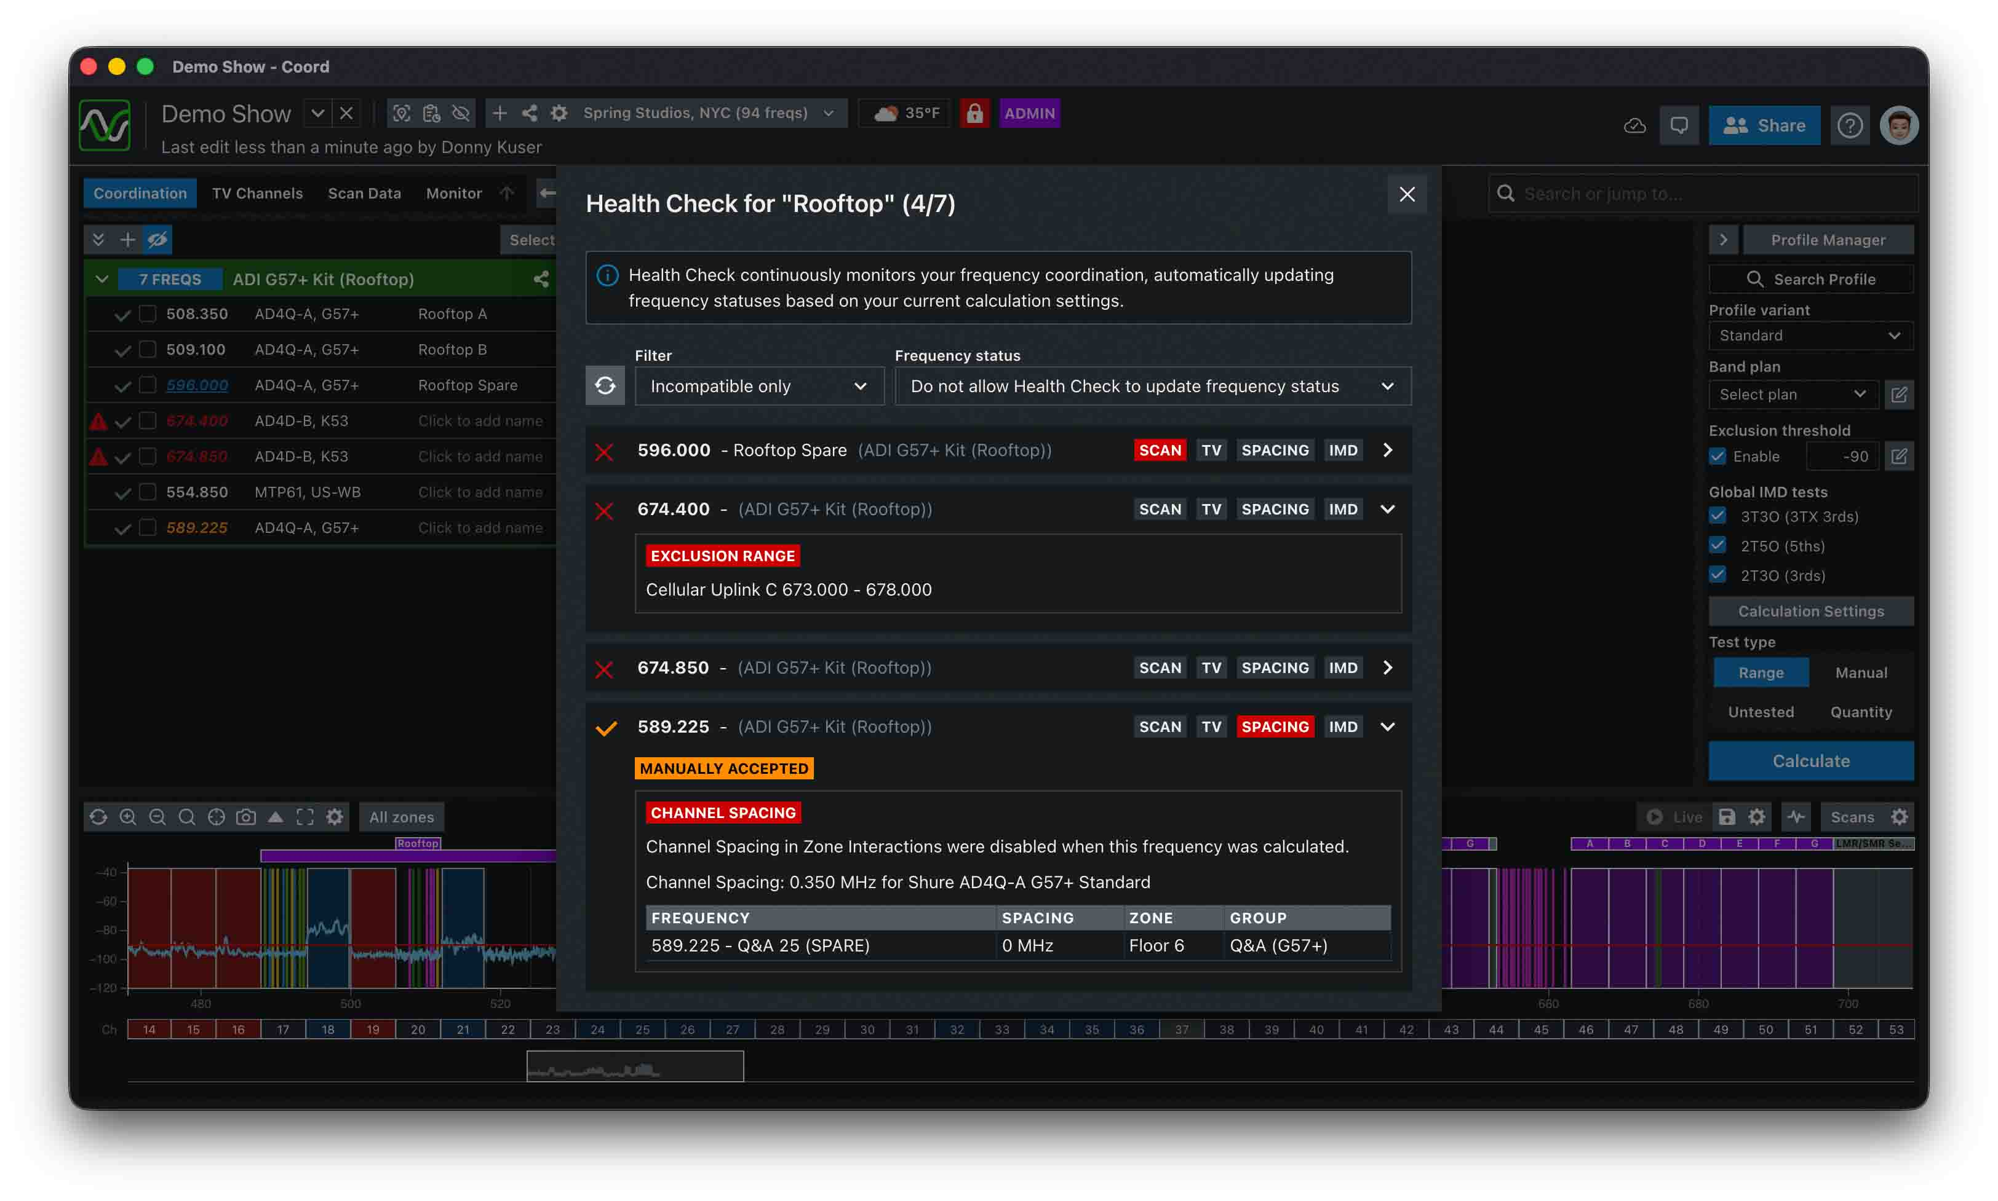

“We’re coordinating close to 1,200 frequencies for 98 bands across five main stages. The new features in SoundBase have been key to optimizing our workflow. The health check, for example, allows us to quickly validate whether our coordination is still accurate and make precise adjustments before assigning frequencies to each band. In addition, the ability to visualize different equipment and networks within the same platform, combined with real-time synchronization across RF coordinators on all stages, has significantly improved our efficiency. These new SoundBase tools truly make a difference, enabling us to work with greater precision and confidence.”
Javier Liberón | RF Coordination and Support, Lollapalooza Chile

https://soundbase.app/
https://www.youtube.com/@soundbaseapp
press@soundbase.app

